INGLÊS - ELEMENTARY III (Activities week 4)
______________________________________________________________

FACEBOOK:

Learn/Practice English with MOVIES (Lesson #3) Title: The Blind Side
https://www.youtube.com/watch?v=JZIL0QLBs4M
FACEBOOK:

SELF INTRODUCTION | How to Introduce Yourself in English | Tell Me About Yourself Interview Answer
https://www.youtube.com/watch?v=QgjkjsqAzvo

Dialogue: “In a restaurant” - Multiple choice exercise

https://www.englishexercises.org/makeagame/viewgame.asp?id=2461

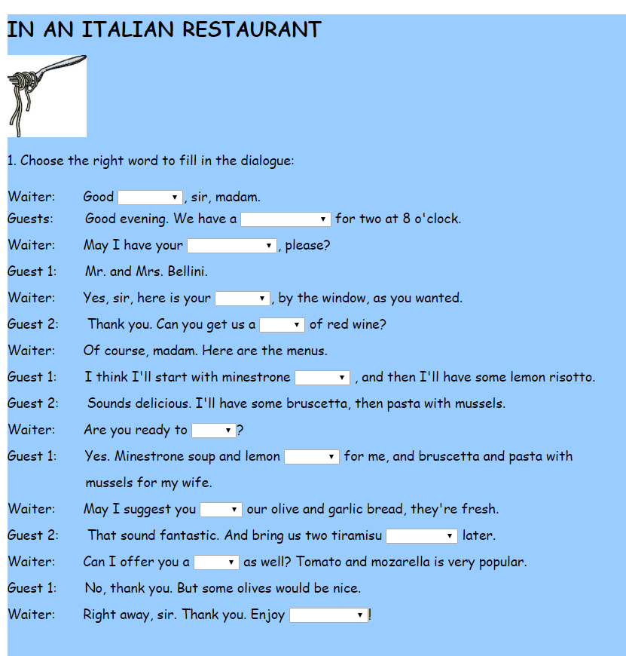

ANSWERS:

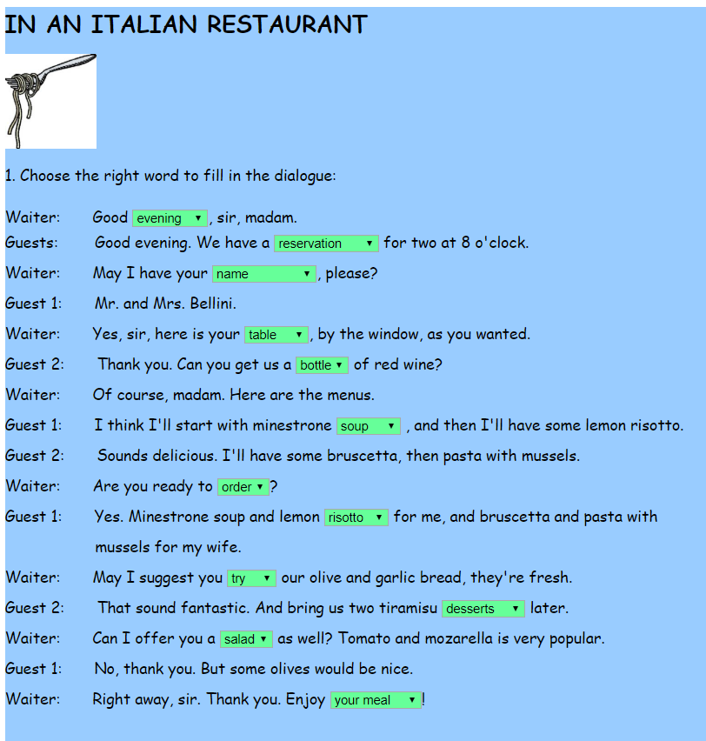

The joke
A fill-in-the-blank reading followed by some activities. It also revises the simple past tense

https://www.englishexercises.org/makeagame/viewgame.asp?id=1505

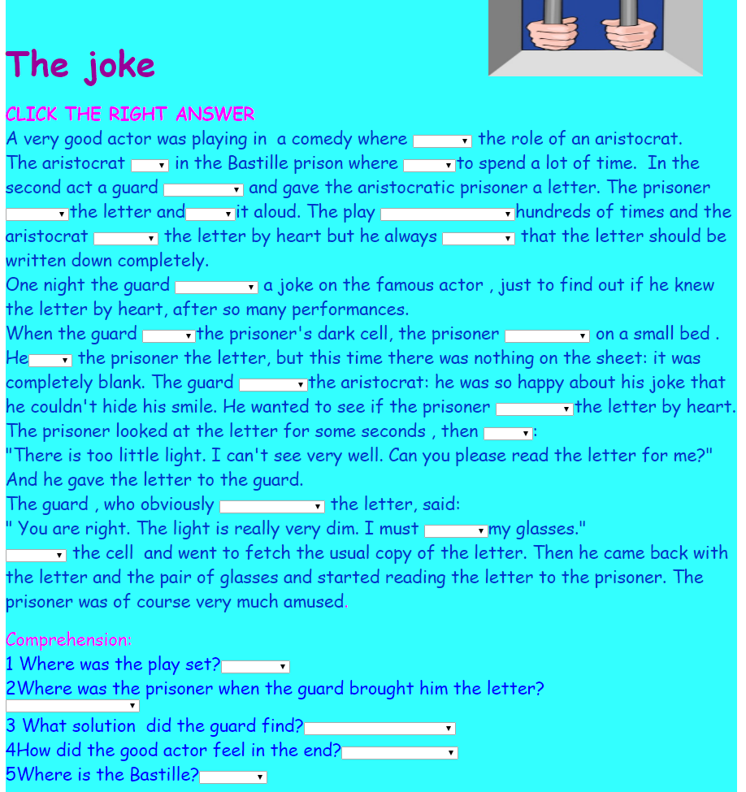

CHECK YOUR ANSWERS:

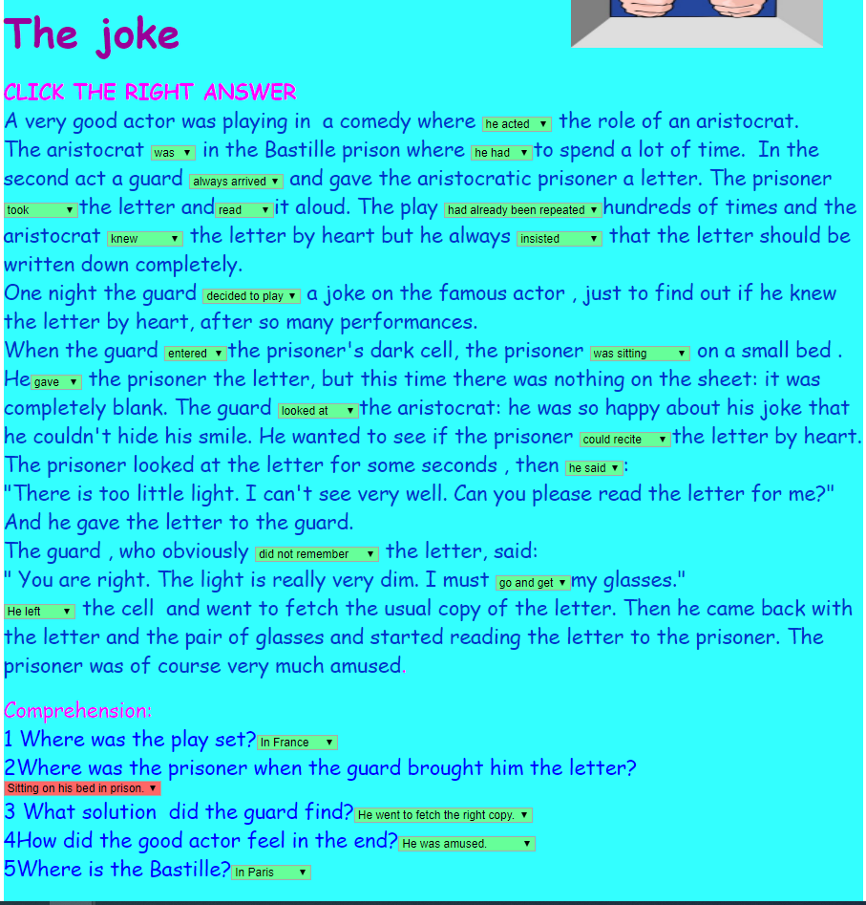

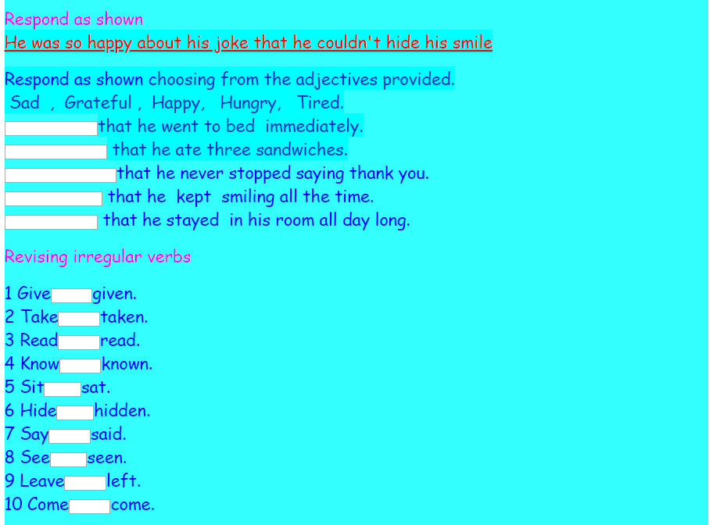

Answers:
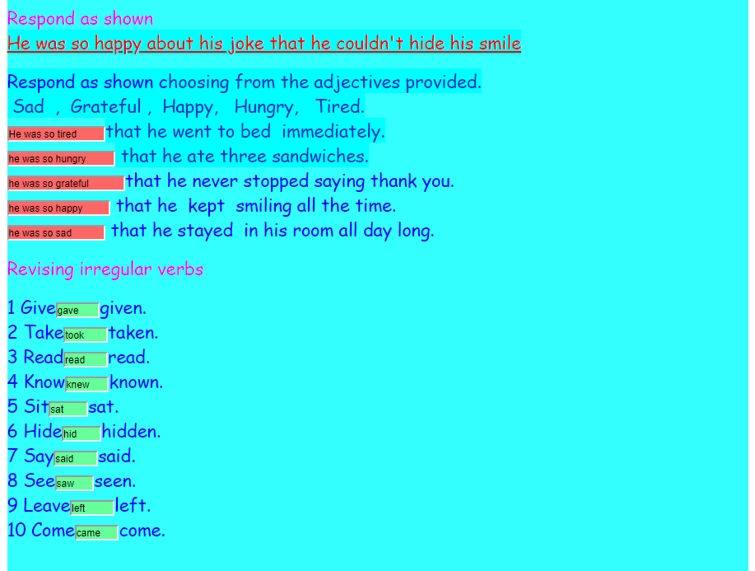

GRAMMAR - PREPOSITIONS OF TIME:

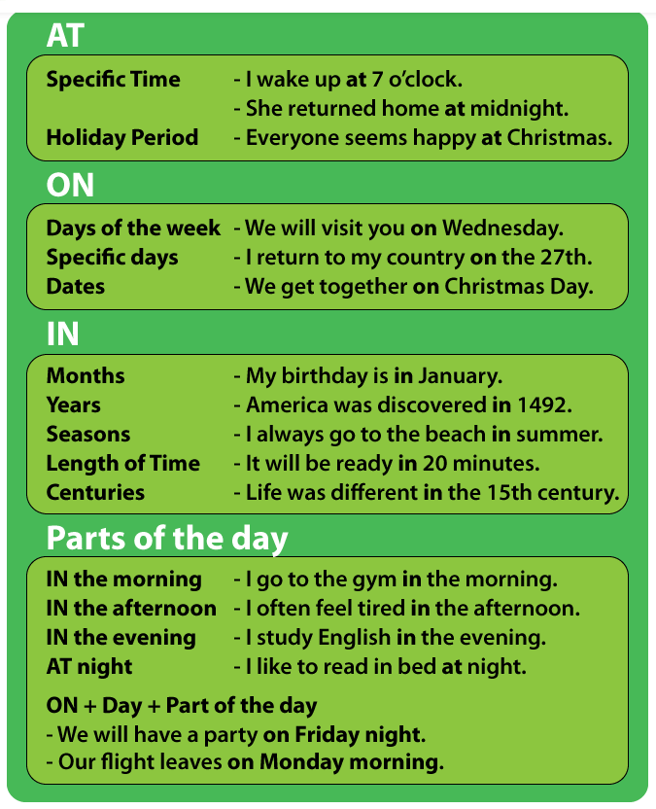

Click on the following link to do the exercises:

https://www.englishexercises.org/exercise.asp?id=2947#a

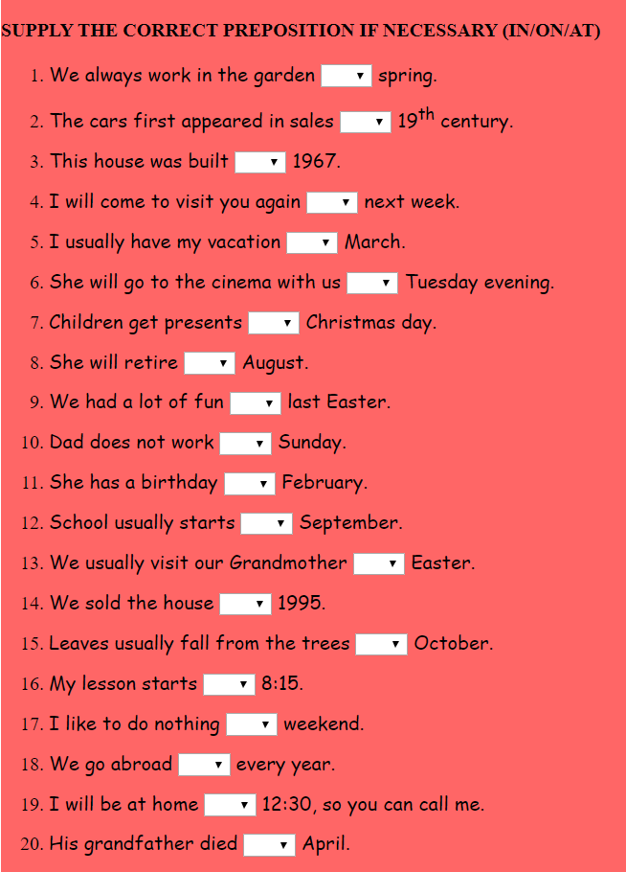

ANSWERS:

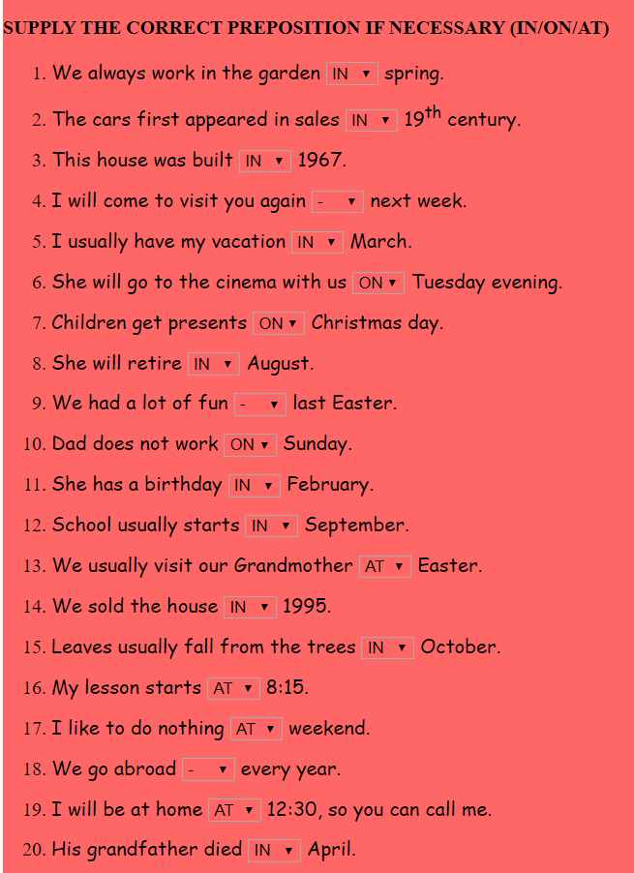

Kátia Vecchi – kcjvecchi@uem.com
__________________________________________________________________________________________

